10.DATA ANALYSIS BY HIERARCHICAL CLUSTERING. IN WEKA

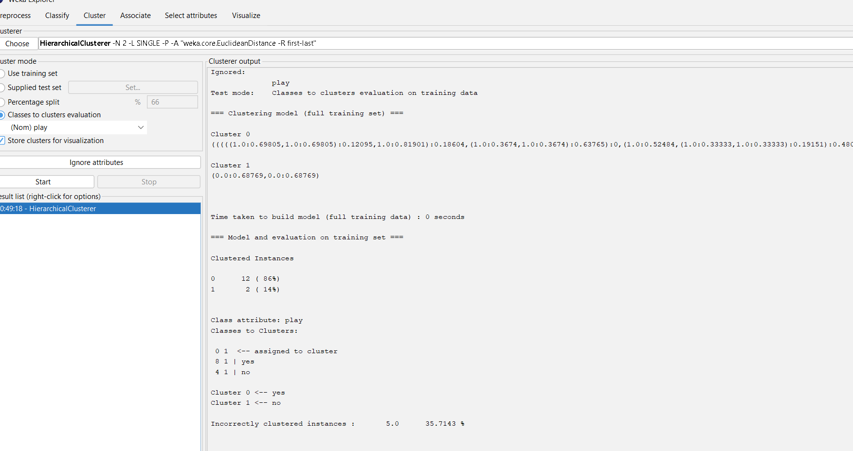

OUTPUT INFORMATION

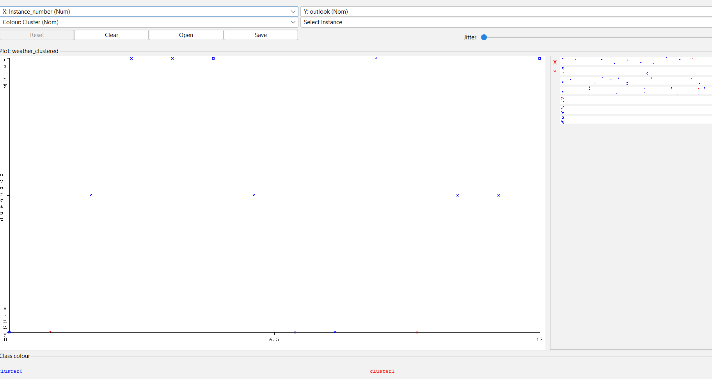

VISUALISING THE PLOT GRAPH OF CLUSTER ASSIGNMENTS

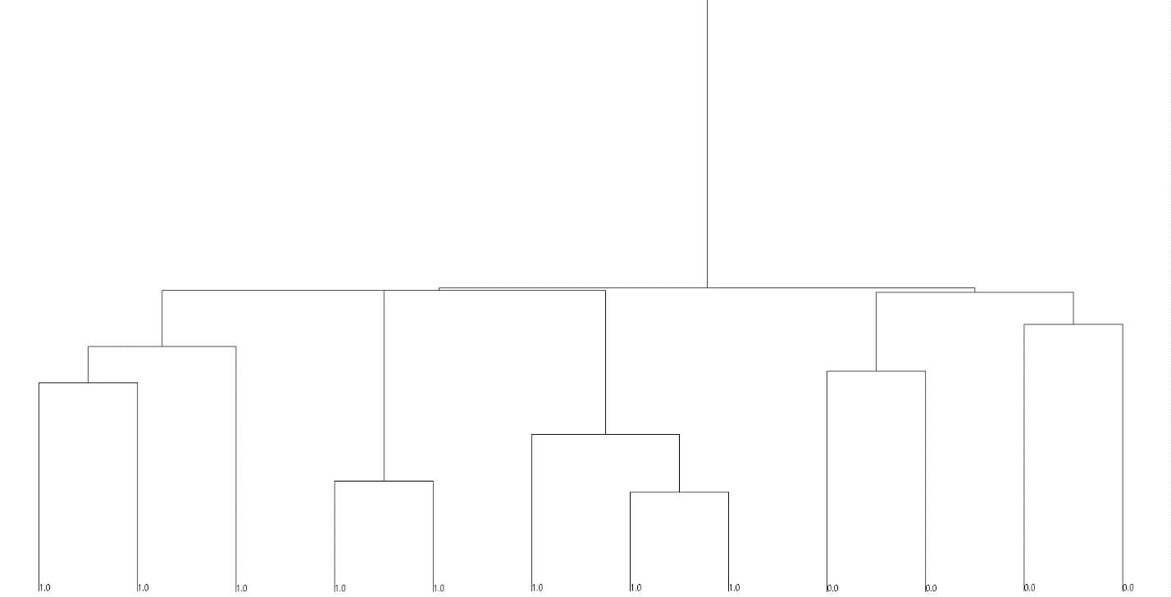

HIERARCHICAL TREE FOR DATA ANALYSIS.